12 - Modules

Dept of Artificial Intelligence and Machine Learning | Rajalakshmi Engineering College

. 149

Ex. No. : 12.1 Date: 8/6/24

Register No.: 231501058 Name: M Harish

Power of 2

Given an integer n, print true if it is a power of two. Otherwise, print false.

An integer n is a power of two, if there exists an integer x such that n == 2x.

For example:



Input | Result
1 | True
8 | False

PROGRAM

import math

n = int(input())

print(n > 0 and math.log2(n).is_integer())

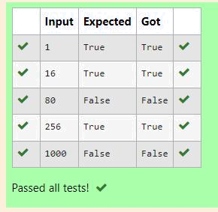

Dept of Artificial Intelligence and Machine Learning | Rajalakshmi Engineering College

. 150

Ex. No. : 12.2 Date: 8/6/24

Register No.: 231501058 Name: M Harish

Square Tiles

Background:

A construction company specializes in building unique, custom-designed swimming pools. One of their popular offerings is circular swimming pools. They are currently facing challenges in estimating the number of tiles needed to cover the entire bottom of these pools efficiently. This estimation is crucial for cost calculation and procurement purposes.

Problem Statement:

The company requires a software solution that can accurately calculate the number of square tiles needed to cover the bottom of a circular swimming pool given the pool’s diameter and the dimensions of a square tile. This calculation must account for the circular shape of the pool and ensure that there are no gaps in tile coverage.

Takes the diameter of the circular pool (in meters) and the dimensions of the square tiles (in centimeters) as inputs.

Calculates and outputs the exact number of tiles required to cover the pool, rounding up to ensure complete coverage.

For example:

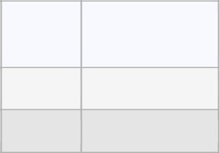

Input

Result

10 20

1964 tiles

10 30

873 tiles

PROGRAM

import math

diameter, tile_size = map(float, input().split())

radius = diameter / 2

area_pool = math.pi * (radius ** 2)

tile_size_m = tile_size / 100

area_tile = tile_size_m ** 2

tiles_needed = math.ceil(area_pool / area_tile)

print(f"{tiles_needed} tiles")

Dept of Artificial Intelligence and Machine Learning | Rajalakshmi Engineering College

. 151

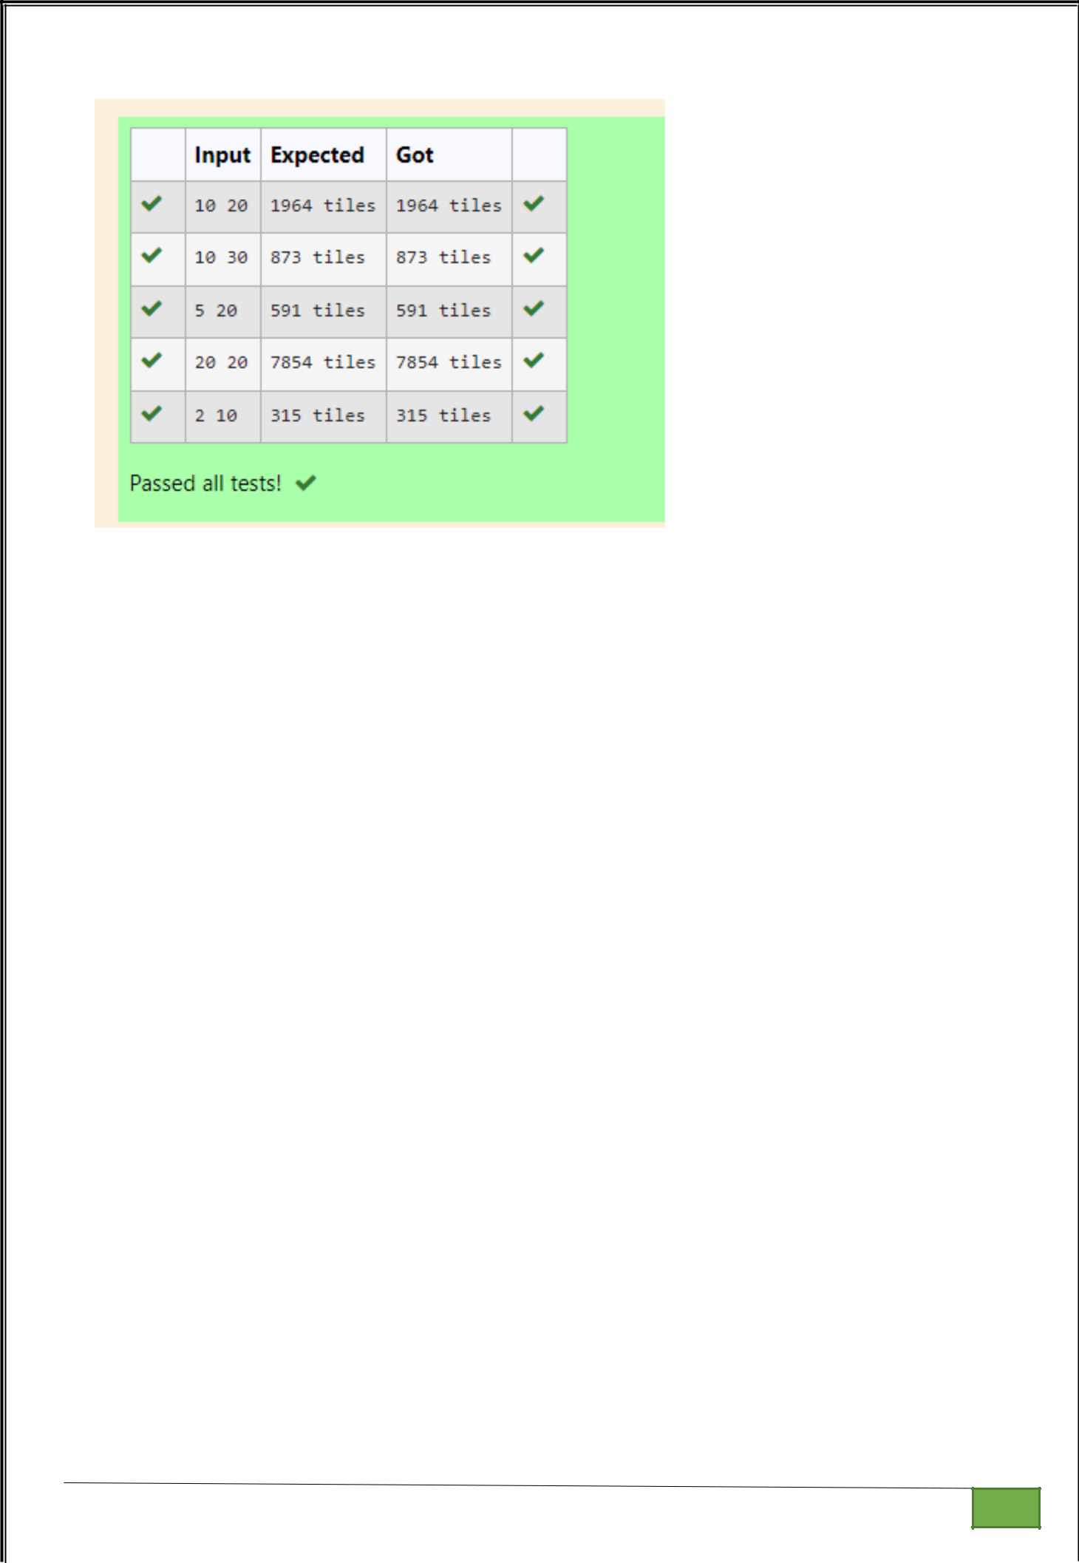

Dept of Artificial Intelligence and Machine Learning | Rajalakshmi Engineering College

. 152

Ex. No. : 12.3 Date: 8/6/24

Register No.: 231501058 Name: M Harish

Shoe Size

Background:

Raghu owns a shoe shop with a varying inventory of shoe sizes. The shop caters to multiple customers who have specific size requirements and are willing to pay a designated amount for their desired shoe size. Raghu needs an efficient system to manage his inventory and calculate the total revenue generated from sales based on customer demands.

Problem Statement:

Develop a Python program that manages shoe inventory and processes sales transactions to determine the total revenue generated. The program should handle inputs of shoe sizes available in the shop, track the number of each size, and match these with customer purchase requests. Each transaction should only proceed if the desired shoe size is in stock, and the inventory should update accordingly after each sale.

Input Format:

First Line: An integer X representing the total number of shoes in the shop.

Second Line: A space-separated list of integers representing the shoe sizes in the shop.

Third Line: An integer N representing the number of customer requests.

Next N Lines: Each line contains a pair of space-separated values:

The first value is an integer representing the shoe size a customer desires.

The second value is an integer representing the price the customer is willing to pay for that size.

Output Format:

Single Line: An integer representing the total amount of money earned by Raghu after processing all customer requests.

Constraints:

1≤X≤1000 — Raghu's shop can hold between 1 and 1000 shoes.

Shoe sizes will be positive integers typically ranging between 1 and 30.

1≤N≤1000 — There can be up to 1000 customer requests in a single batch.

The price offered by customers will be a positive integer, typically ranging from $5 to $100 per shoe.

Dept of Artificial Intelligence and Machine Learning | Rajalakshmi Engineering College

. 153

For example:

Input |  |  |  | Result
10 |  |  |  | 200
2 | 3 4 | 5 6 8 | 76518
6
6 | 55
6 | 45
6 | 55
4 | 40
18 | 60
10 | 50
5 |  |  |  | 50
5 | 5 5 | 5 5
5
5 | 10
5 | 10
5 | 10
5 | 10
5 | 10

PROGRAM

no_of_shoes=int(input())

size=input().split()

size=[int(x) for x in size]

customers=int(input())

total=0

for i in range(customers):

new=input().split()

new=[int(x) for x in new]

if new[0] in size:

size.remove(new[0])

total+=new[-1]

print(total)

Dept of Artificial Intelligence and Machine Learning | Rajalakshmi Engineering College | . 154

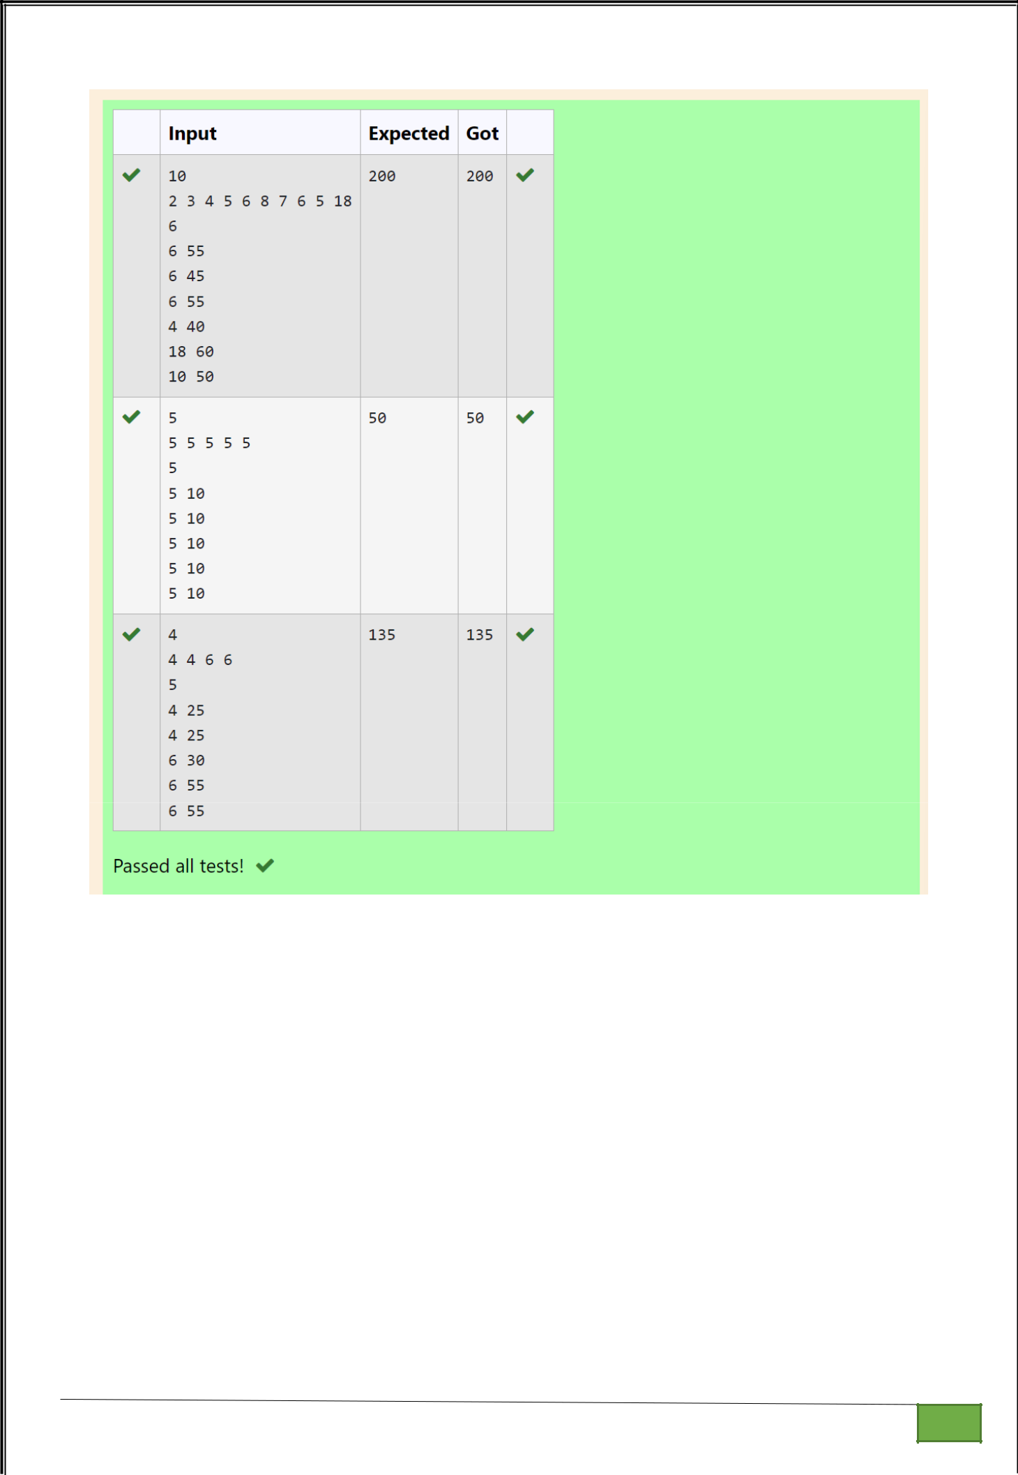

Dept of Artificial Intelligence and Machine Learning | Rajalakshmi Engineering College

. 155

Ex. No. : 12.4 Date: 8/6/24

Register No.: 231501058 Name: M Harish

Count Unique Pairs

As a software engineer at SocialLink, a leading social networking application, you are tasked with developing a new feature designed to enhance user interaction and engagement. The company aims to introduce a system where users can form connections based on shared interests and activities. One of the feature's components involves analyzing pairs of users based on the activities they've participated in, specifically looking at the numerical difference in the number of activities each user has participated in.

Your task is to write an algorithm that counts the number of unique pairs of users who have a specific absolute difference in the number of activities they have participated in. This algorithm will serve as the backbone for a larger feature that recommends user connections based on shared participation patterns.

Problem Statement

Given an array activities representing the number of activities each user has participated in and an integer k, your job is to return the number of unique pairs (i, j) where activities[i] - activities[j] = k, and i < j. The absolute difference between the activities should be exactly k.

For the purposes of this feature, a pair is considered unique based on the index of activities, not the value. That is, if there are two users with the same number of activities, they are considered distinct entities.

Input Format

The first line contains an integer, n, the size of the array nums.

The second line contains n space-separated integers, nums[i].

The third line contains an integer, k.

Output Format

Return a single integer representing the number of unique pairs (i, j)

where | nums[i] - nums[j] | = k and i < j.

Constraints:

1 ≤ n ≤ 105

-104 ≤ nums[i] ≤ 104

0 ≤ k ≤ 104

For example:

Dept of Artificial Intelligence and Machine Learning | Rajalakshmi Engineering College

. 156

Input |  |  |  | Result
5 |  |  |  | 1
1 | 3 1 | 5 | 4
0
4 |  |  |  | 4
1 | 2 2 | 1
1

PROGRAM

n=int(input())

l=input().split()

l=[int(x) for x in l]

k=int(input())

sum=0

for i in range(len(l)):

for j in range(i+1,len(l)):

if abs(l[i]-l[j])==k :

sum+=1

print(sum)

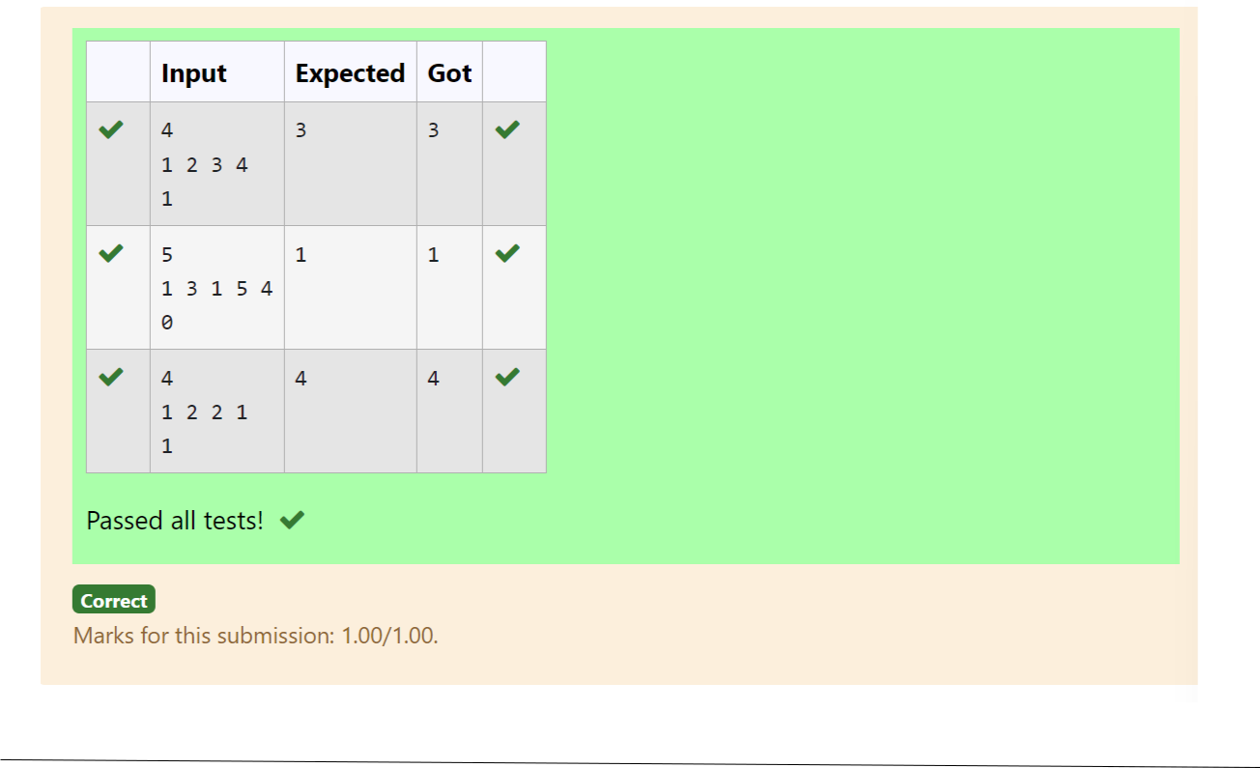

Dept of Artificial Intelligence and Machine Learning | Rajalakshmi Engineering College | . 157

Ex. No.

:
12.5
Date: 8/6/24

Register No.: 231501058

Name: M Harish

Calculate Average Marks

Background:

Dr. John Wesley maintains a spreadsheet with student records for academic evaluation. The spreadsheet contains various data fields including student IDs, marks, class names, and student names. The goal is to develop a system that can calculate the average marks of all students listed in the spreadsheet.

Problem Statement:

Create a Python-based solution that can parse input data representing a list of students with their respective marks and other details, and compute the average marks. The input may present these details in any order, so the solution must be adaptable to this variability.

Input Format:

The first line contains an integer N, the total number of students.

The second line lists column names in any order (ID, NAME, MARKS, CLASS). The next N lines provide student data corresponding to the column headers. Output Format:

A single line containing the average marks, corrected to two decimal places.

Constraints:

1≤N≤100

Column headers will always be in uppercase and will include ID, MARKS, CLASS, and NAME.

Marks will be non-negative integers.

Dept of Artificial Intelligence and Machine Learning | Rajalakshmi Engineering College | . 158

For example:

Input |  | Result
3 |  | 84.33
ID NAME MARKS CLASS
101 John 78 Science
102 Doe 85 Math
103 Smith 90 History
3 |  | 84.33
MARKS CLASS NAME ID
78 | Science John 101
85 | Math Doe 102
90 | History Smith 103

PROGRAM

import math

n = int(input())

columns = input().split()

marks_index = columns.index("MARKS")

total_marks = 0

for _ in range(n):

data = input().split()

total_marks += int(data[marks_index])

average_marks = total_marks / n

print(f"{average_marks:.2f}")

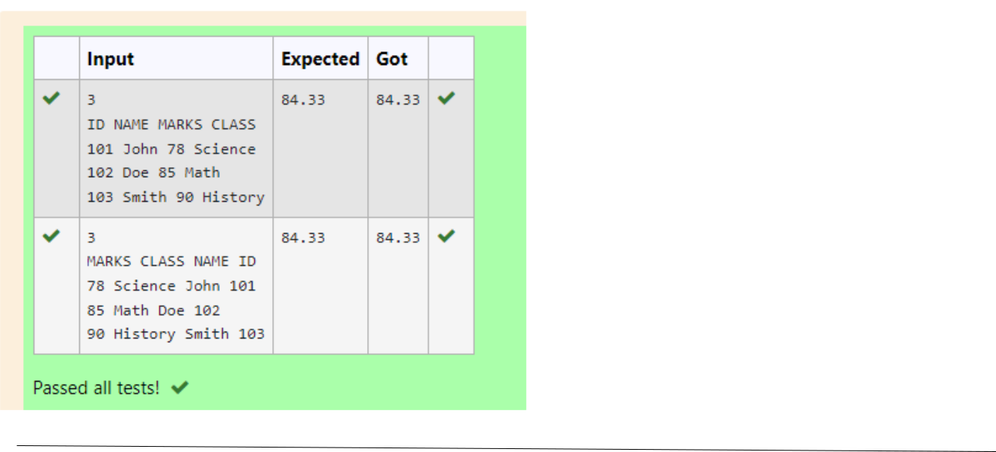

Dept of Artificial Intelligence and Machine Learning | Rajalakshmi Engineering College | . 159

